**Build a network for Smart Building**

| Archis Khuspe | Ashfan Khan |
| --- | --- |
| *SY, E&TC* | *SY, E&TC* |
| *Vishwakarma Institute of Technology* | *Vishwakarma Institute of Technology* |
| *Pune, India* | *Pune, India* |
| archis.khuspe20@vit.edu | ashfan.khan20@vit.edu |

| Atharv Patil |  | Avdhut Asore |
| --- | --- | --- |
| *SY, E&TC* |  | *SY, E&TC* |
| *Vishwakarma Institute of Technology* |  | *Vishwakarma Institute of Technology* |
| *Pune, India* |  | *Pune, India* |
| atharv.patil20@vit.edu |  | avdhut.asore20@vit.edu |
|  |  |

*Abstract— This paper aims to present an implementation of IoT smart buildings using the virtual network in Cisco Packet Tracer visual simulation tool. The rationale of smart buildings is not only to improve wireless connectivity but also to enhance life quality and safety in various aspects of people’s life. The IoT architecture considers security, fire safety, energy management, and a wide range of smart devices including RFID and lighting. This project aims to simulate smart devices that can respond independently or be controlled by end-users remotely to drive efficiency and effectiveness. Simulation results using Cisco Packet Tracer show that enabling IoT to buildings is a promising and cost-effective approach that pursues the aim of this article in a timely and efficient manner.*

***Keywords— IoT, Cisco Packet Tracer, Devices, Simulation, Communication, Network.***

I. INTRODUCTION

The Internet of Things (IoT) is a new age of computer technology that enables the processing and sharing of data by connecting things with electronics, software and sensors to the internet. Things can be anything and everything. IoT is one of the promising technologies by which intelligent objects connected to the internet through an IP address can be controlled and managed. As a result, the Internet of Things is predicted to affect life significantly.

IoT architecture can be divided into three layers:

* ***Perception Layer:*** The perception layer includes physical objects, such as sensors, actuators, and RFID tags, which aim to recognize things, collect information of interest, and convert this information into digital data. Depending on the type of sensors, the collected information can be temperature, humidity, location and current. The digitised signal is then passed to the network layer through secure channels.
* ***Network Layer:*** The network layer (or transmission layer) transfers the data from the perception layer to the application layer.
* ***Application Layer:*** The application layer provides users or consumers with different high-quality services and applications. Many intelligent applications such as grids, transportation, and healthcare are implemented in this layer. In addition, it provides an interface for customers to communicate with a physical device or access the specified data.

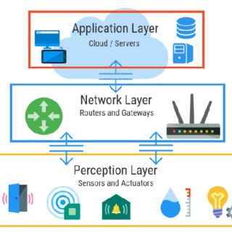

Fig. 1 The three layers of IoT architecture

II. LITERATURE REVIEW

[1] This paper proposes an efficient rule engine for intelligent building systems, which can guarantee a real-time response to events and a quick match between events and rules. A rule engine adaption scheme based on the rule matching feedback has been proposed, which can dynamically decrease the law matching overhead. Finally, implementing the proposed rule engine and verifying its effectiveness in the building system are done. A series of experimental results show that the proposed scheme can significantly improve the rule execution performance even with abundant data and an extensive ruleset. [2] This paper proposed a methodology for developing an ANN-based model for forecasting indoor temperature. Relevance analysis and different input parameters could lead to a simplified forecasting model with restricted input parameters. Through its application to data collected in an old building, the data included outdoor and indoor temperature, humidity, and solar radiation. Analyses showed that two-hour facade temperature forecasting could be conducted with good precision using only the outdoor temperature and three-hour facade temperature history. Temperature sensors can use the methodology for measuring outdoor and indoor facade temperatures. [3] The technologies surveyed in this work present new and better solutions for making Smart Cities more efficient. With multiple sensors installed in a Smart Building, a better monitoring system of the whole building is achieved. This paper surveyed the Internet of Things, Cloud Computing, Big Data and Sensors technologies to find their everyday operations and combine them. New methods to collect and manage sensors' data in an intelligent building have been proposed, which operate in an IoT environment. The solutions for organising and managing sensors' data in an intelligent building could lead to an energy-efficient smart building. [4] This paper has investigated the inaccuracy problem of IoT network algorithms using heterogeneous input data. By introducing complex network and clustering techniques, this heterogeneous data can be virtualized into segmented virtual layers considering the clusters to transform it into homogeneous data that optimises the operation of the algorithms using the virtual segmentation technique. The algorithms guarantee an optimised performance considering the different areas of the topology of the IoT network. Finally, a case study result demonstrates the efficacy of the proposed IoT slicing method. [5] Various features of Smart Building such as privacy and security, health services, safety and building management systems are improved because of IoT protocols in Smart Building Architecture. The main focus is on sensing and controlling the IoT infrastructure which enables the cloud clients to use a virtual sensing infrastructure using communication protocols. [6] In this paper, architecture for a smart building system, including a control system and automatic approaches, is proposed. Blockchain technology is performed for transferring data within the smart building. A cluster head selection algorithm is also proposed in this paper to select the desired cluster head with the consideration of low energy consumption and fast head selection.

III. METHODOLOGY

1. *Components Used*

* ***Cisco Packet Tracer version 8.1.1:***

Cisco Packet Tracer is a powerful virtual network simulation tool used to learn and understand the different concepts in computer networks. Cisco developed the tool to give users practical knowledge of networking technology. It allows users to design and simulate a network using virtual devices such as a hub, router and switches. The simulation works without having any physical network.

1. The software has two workspaces:

* ***Logical:*** It allows the user to place and connect virtual network devices
* ***Physical:*** Physical view gives a graphical representation of the virtual network devices.

1. It also has two modes:

* ***Real-time:*** In real-time, users can see how the devices behave. In this mode, devices behave as real devices.
* ***Simulation mode:*** It helps users understand the fundamental concept behind the network operations. This mode permits the user to see and control time intervals and visualise data propagation across a network.

1. *Implementation*

The network for the IoT system is logically separated into three areas: sensors, servers, and devices. All IoT devices are connected to the router in the control centre. They are wired to the microcontroller, which is wirelessly connected to the home gateway. The home gateway broadcasts the data to the cloud via a modem. The data is archived in servers and can be accessed by end-user devices through the cell tower and wireless connections.

Internet settings in the router were the wireless Service Set Identifier (SSID) and password. The same SSID, password and Dynamic Host Configuration Protocol (DHCP) default settings were used across all wireless devices, while the local server used static IP. Static IP addresses ensure that if the WLAN router is rebooted, the server IP remains the same, and there won’t be any need to re-configure the devices assigning new IoT server IPs. In addition, these functionalities ensure that there is backend intelligence to the IoT simulation and facilitate the hosting of the IoT homepage where end-users can connect and interact with the building.

The intelligent devices are remotely connected to the IoT backend server. The IoT connection enables the users to check the status of the IoT devices from an IoT browser homepage. The IoT browser homepage shows a list of the intelligent devices, allows visualisation of their status, and permits remote interaction with the devices. Logical interaction between smart devices can also be set while connected to the IoT main homepage. Interactions between devices are based on set conditions. The central control and smartphones, connected to the local central office wireless LAN (WLAN), can connect to the dedicated IoT homepage via a browser to monitor all connected IoT devices.

The list of IoT functionalities include:

* Radio Frequency Identification (RFID) based door lock
* Solar battery powered devices such as LED, lamp, fan etc.
* Remotely controllable devices such as fan, coffee maker, music player etc.
* Auto dimming street lamp based on the time of the day
* Garage that opens in the presence of a car using a smoke detector
* Fire sprinkler system with a siren

Cisco Packet Tracer has a feature with the possibility to switch from a real-time to a simulation model. The first mode enabled the possibility to create the underneath network, connect IoT devices, and define IoT backend logic. However, only in the simulation mode could it be possible to validate that the network communication layer happened between the devices. In the simulation model, it was possible to simulate packet traffic between nodes and devices to check the connectivity, routing protocols, and other network logic.

IV. RESULT

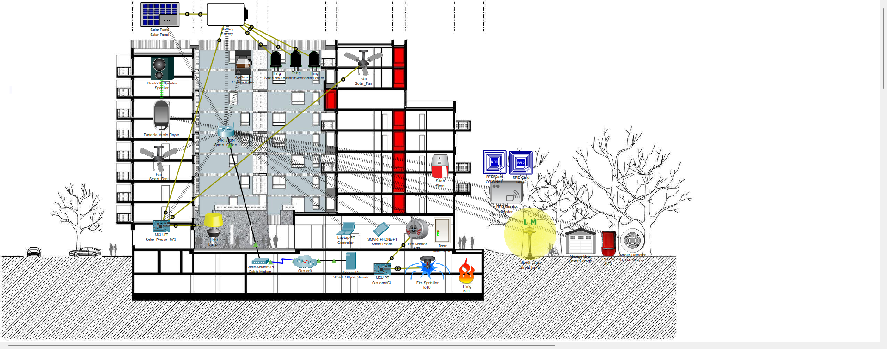

Fig. 2 Cisco Packet Tracer layout of Smart Building simulation.

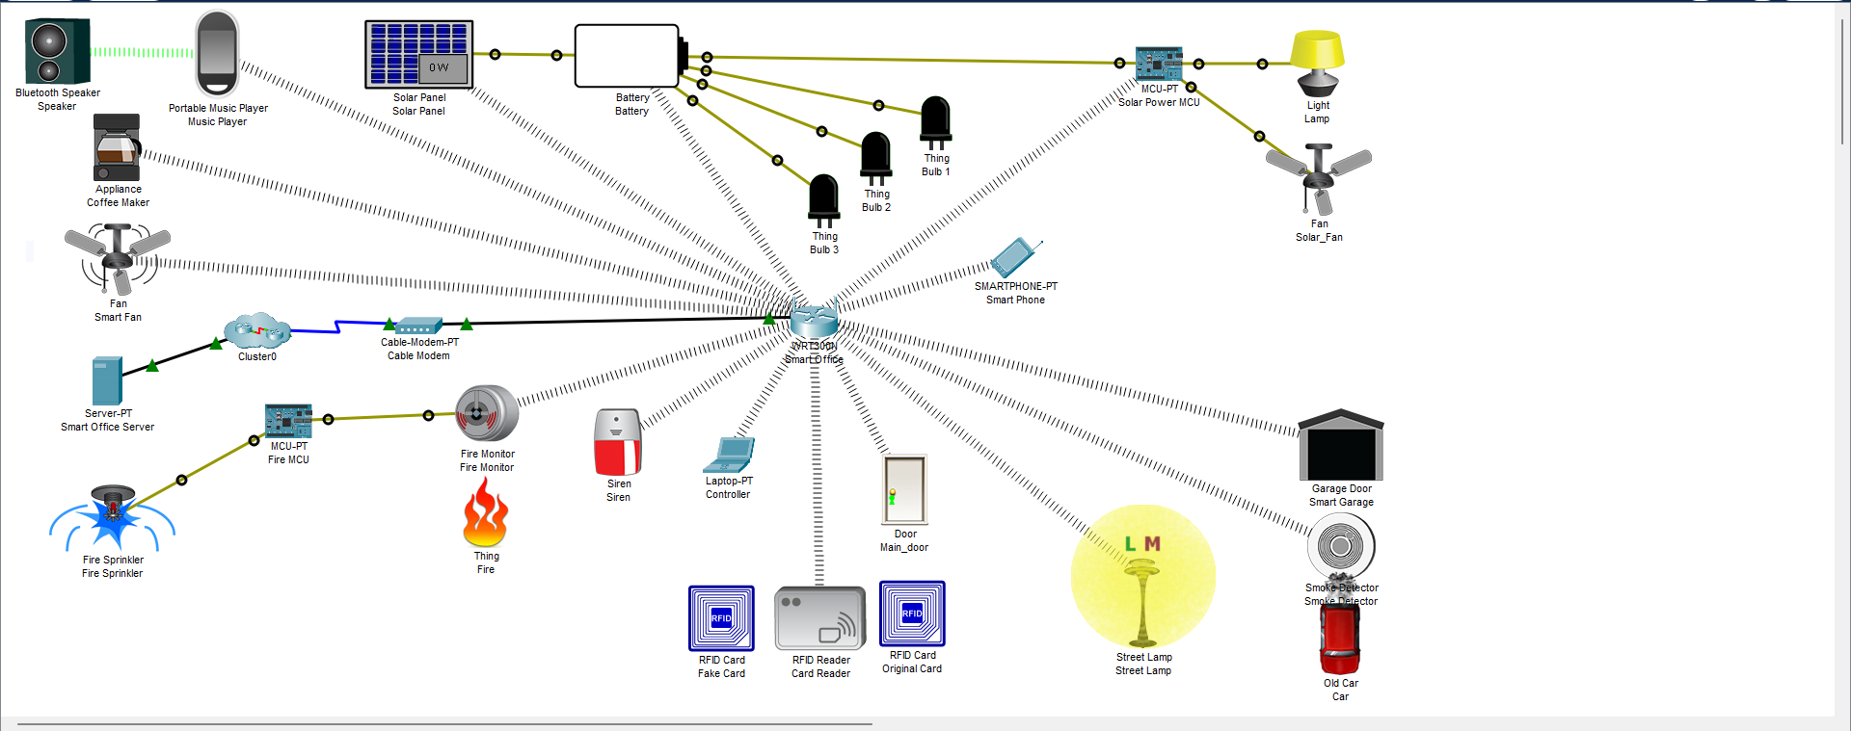

Fig. 3 Simplified layout

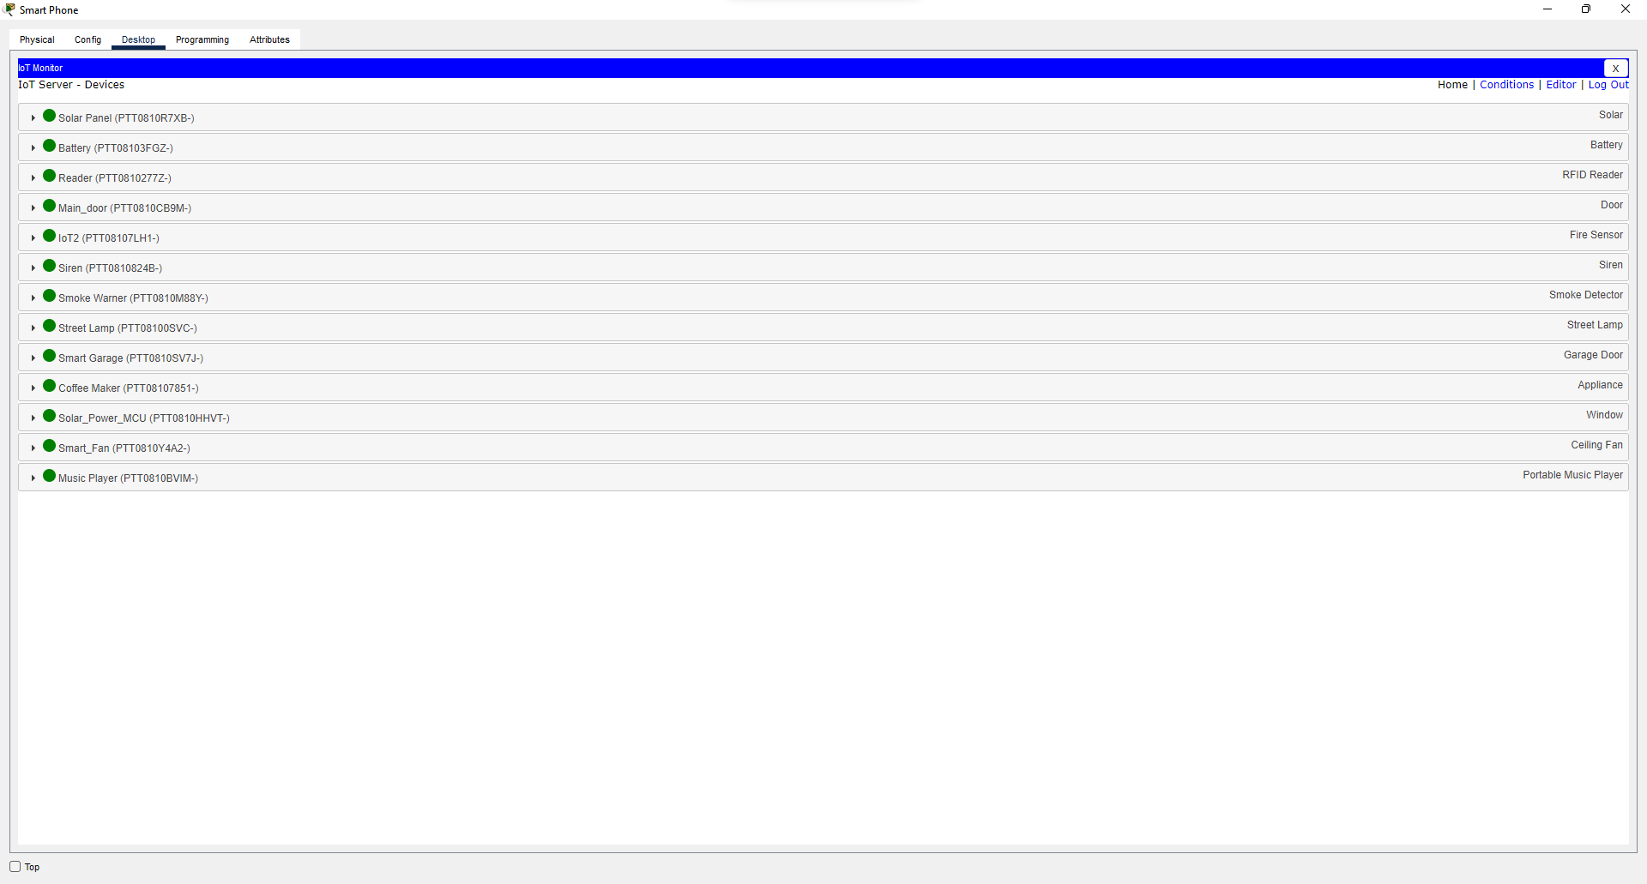

Fig. 4 Connected IoT devices

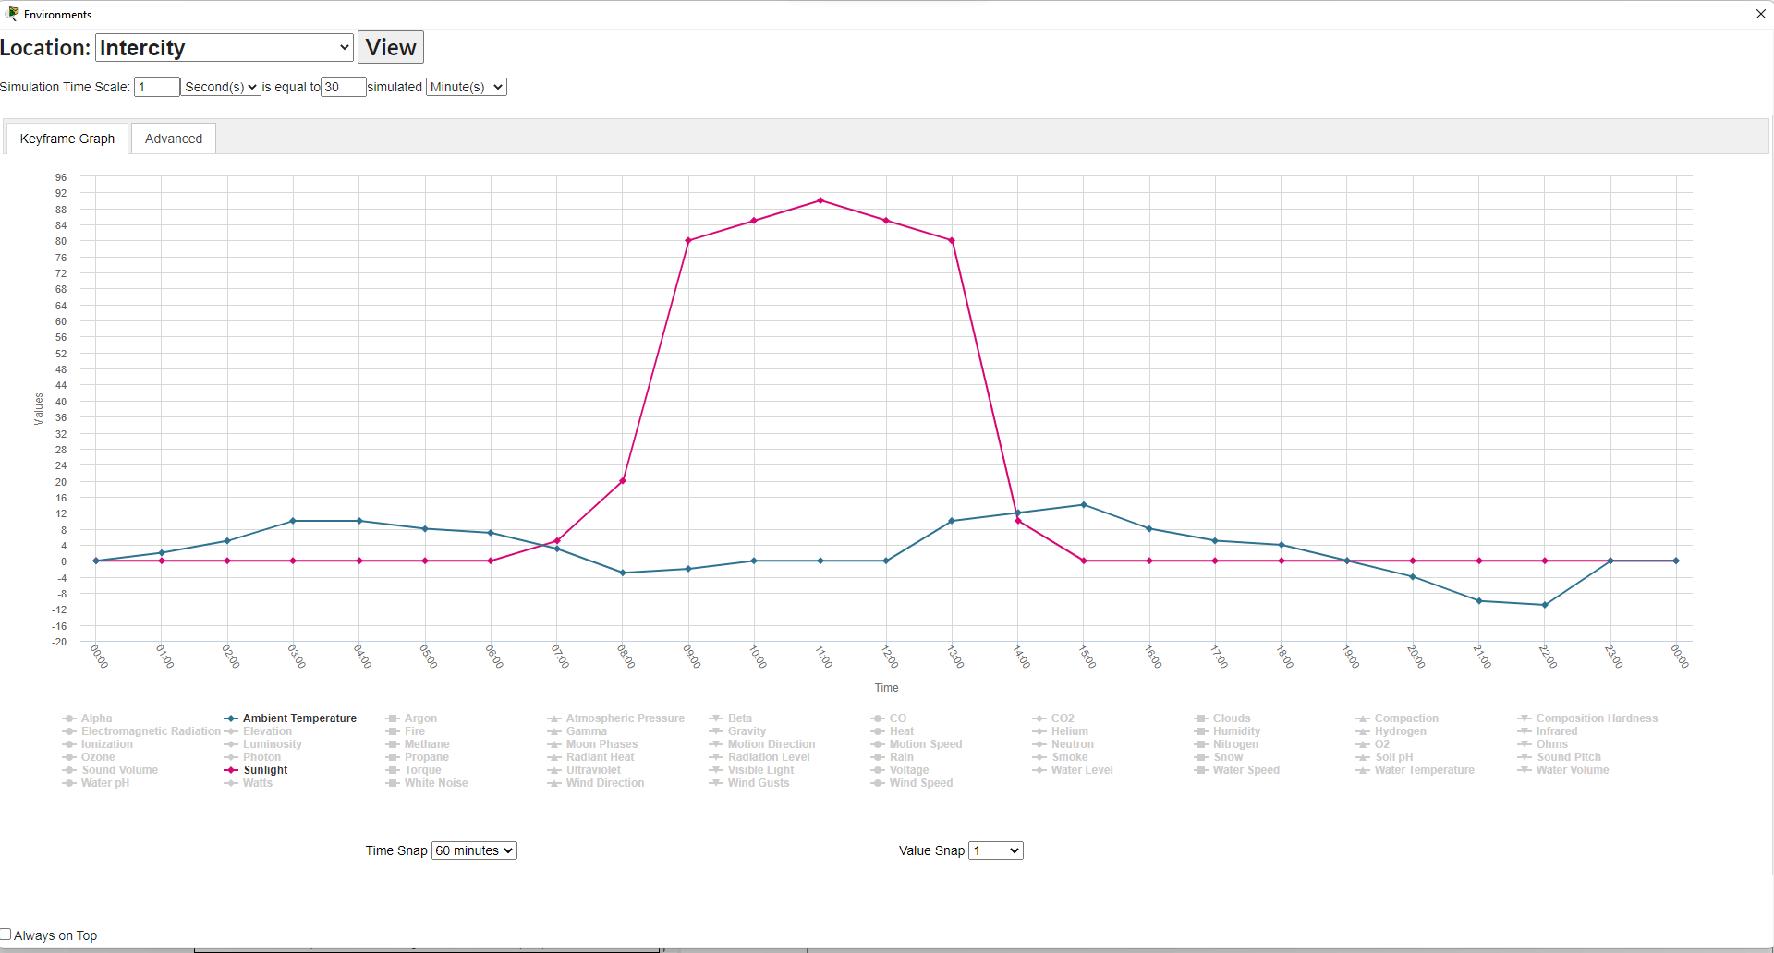

Fig. 5 Environment Simulation

V. FUTURE SCOPE & CONCLUSION

In the era of digital societies, one must create intelligent buildings that can bring comfort, efficiency, safety and security. The design, simulation, and implementation of IoT smart buildings were done using the virtual network in the Cisco Packet Tracer tool. The IoT architecture considers security, fire safety, energy management, intelligent devices including RFID, and lightning for smart buildings. The simulation results show that enabling IoT to buildings proves that there is a great potential to apply this model in real life in various domains for security, comfort, improving energy efficiency, and reducing costs.

REFERENCES

[1] Y. Sun, T. Wu, G. Zhao and M. Guizani, "Efficient Rule Engine for Smart Building Systems," in IEEE Transactions on Computers, vol. 64, no. 6, pp. 1658-1669, 1 June 2015, doi: 10.1109/TC.2014.2345385.

[2] Attoue, N.; Shahrour, I.; Younes, R. Smart Building: Use of the Artificial Neural Network Approach for Indoor Temperature Forecasting. Energies 2018, 11, 395. https://doi.org/10.3390/en11020395

[3] Andreas P. Plageras, Kostas E. Psannis, Christos Stergiou, Haoxiang Wang, B.B. Gupta, Efficient IoT-based sensor BIG Data collection–processing and analysis in smart buildings, Future Generation Computer Systems, Volume 82, 2018, Pages 349-357, ISSN 0167-739X, https://doi.org/10.1016/j.future.2017.09.082.

[4] Roberto Casado-Vara, Angel Martin-del Rey, Soffiene Affes, Javier Prieto, Juan M. Corchado, IoT network slicing on virtual layers of homogeneous data for improved algorithm operation in smart buildings, Future Generation Computer Systems, Volume 102, 2020, Pages 965-977, ISSN 0167-739X, https://doi.org/10.1016/j.future.2019.09.042.

[5] A. Verma, S. Prakash, V. Srivastava, A. Kumar and S. C. Mukhopadhyay, "Sensing, Controlling, and IoT Infrastructure in Smart Building: A Review," in IEEE Sensors Journal, vol. 19, no. 20, pp. 9036-9046, 15 Oct.15, 2019, doi: 10.1109/JSEN.2019.2922409.

[6] A. Rahman, M. K. Nasir, Z. Rahman, A. Mosavi, S. S. and B. Minaei-Bidgoli, "DistBlockBuilding: A Distributed Blockchain-Based SDN-IoT Network for Smart Building Management," in IEEE Access, vol. 8, pp. 140008-140018, 2020, doi: 10.1109/ACCESS.2020.3012435.